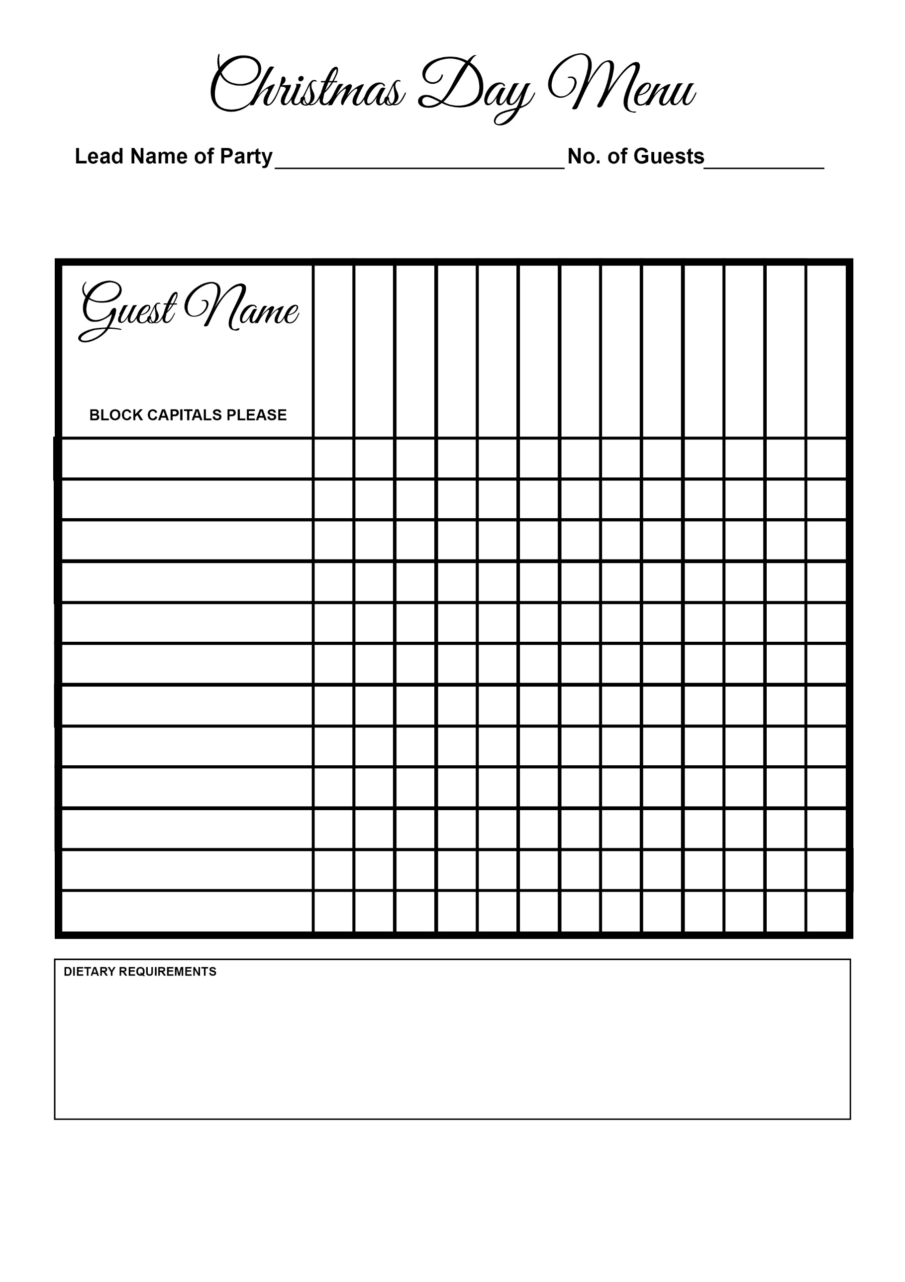

Selection Of Cheeses

Christmas Pudding

Bread & Butter Pudding

Blue Cheese Tart

Parfait

Sea Bass

Beef

Turkey

Mediterranean Vegetable

Soup

Salmon & Prawn

Venison