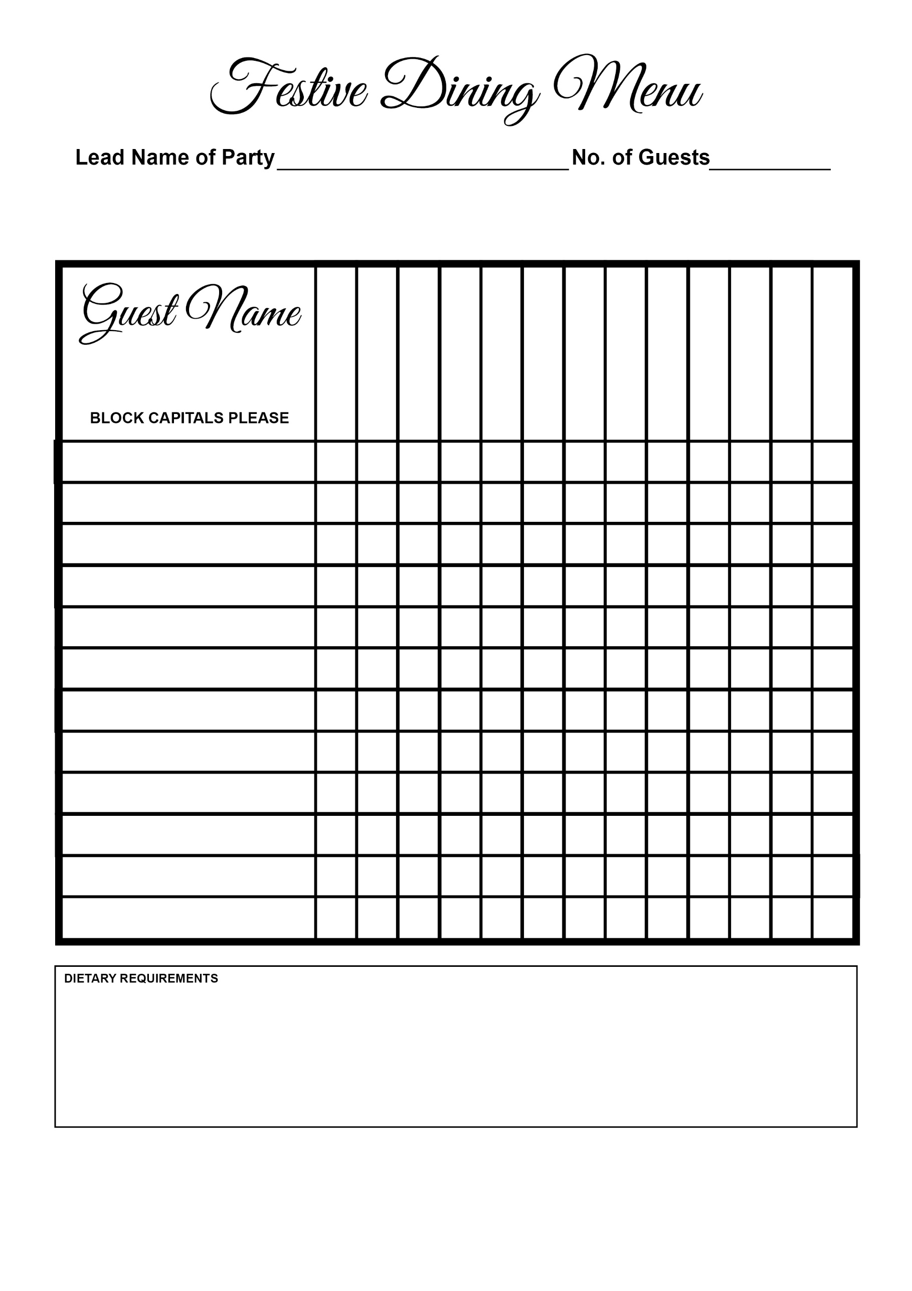

Christmas Pudding

Cheesecake

Chocolate Tart

Butternut Squash

Salmon

Lamb

Turkey

Smoked Haddock

Melon

Soup